Data Tier.Net Quick Start

**Setting up Data Tier.Net**

Update 3.30.2022: **Major Milestone**

DataTier.Net 3.2.0 has been released and now works with .NET5 / .NET6.

The project templates are different for .Net Framework and .Net Core.

.NET5 and.NET6 project templates are installed via Nuget.

**.Net Framework vs NET5 / .NET6**

The only usage difference is with .NET5 & .NET6, you must create a system environment variable to hold the connection string.  
  
**DataGateway**

Create a new instance of a Gateway object, pass in the environment variable name.

.NET5 / .NET6

// create a new gateway object and pass in the connectionName

Gateway gateway = new Gateway(connectionName);

// .NET Framework, the connection string is read from the app or web.config

Gateway gateway = new Gateway();

**Installing Project Templates**

The Setup Control (shown on the next page), has options for .NET Framework and .NET5 / .NET6.

The .NET Framework project templates are for version 4.6.1. You can upgrade them after installing to 4.8 project framework.

Update 7.21.2019: I created a new setup control:

There are three steps to setting up DataTier.Net:

**Step 1. Create DataTier.Net SQL Server Database**

Create a new database named ‘DataTier.Net.Database’ in SQL Server Management Studio.

Check the box ‘DataTier.Net.Database has been created’.

This will enable the link to the file:



Execute this SQL script to create the tables and procedures:

DataTier.Net\DataTier.Net\Database\SQL Scripts\DataTier.Net.Schema.sql

**Step 2: Install DataTier.Net Project Templates:**

**.NET Framework**

Click the link ‘Install DataTier.Net Project Templates.vsix’.

This will launch the Visual Studio Extension Installer:

Note: I only have Visual Studio 2019 installed now. The options show here may be different depending on if you VS 2017, VS2019 or both on your system.

**.NET5 / .NET6**

Make sure you are connected to the internet and click the link for either .NET5 or .NET6 Project Templates. This will install the Nuget package:

DataJuggler.DataTier.Net5.ProjectTemplates

or

DataJuggler.DataTier.Net6.ProjectTemplates

There are buttons for this, but if you prefer a command line:

**Command Line**

dotnet new -i DataJuggler.DataTier.Net5.ProjectTemplates

dotnet new -i DataJuggler.DataTier.Net6.ProjectTemplates

**Uninstall**

For .NET Framework, manage extensions in Visual Studio.

For .NET5 or .NET6, click the Uninstall Project Templates buttons.

**Command Line**

dotnet new -u DataJuggler.DataTier.Net5.ProjectTemplates

**or**

dotnet new -u DataJuggler.DataTier.Net6.ProjectTemplates

**Step 3: Build Connectionstring & Setup App.config**

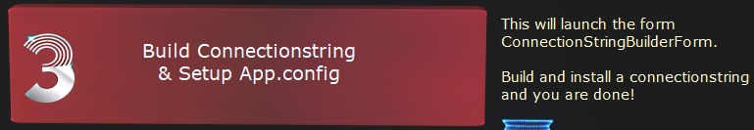

Click the link ‘Build Connectionstring & Setup App.config’.

As the screenshot above indicates, this will launch the ConnectionStringBuilderForm.

**7.21.2019: New Connection String Builder**

The old Connection String Builder was a stand-alone application and is still in the Tools folder. This works fine, although it added an extra couple of minutes to every tutorial video. I had to explain you must compile Connection String Builder before the ‘Launch Connection String Builder’ button is clicked because Git Hub does not include .exe’s when you clone.

The new version is much easier to use as I now update the app.config for the user with an ‘Install Conn String & Update App.config’ button:

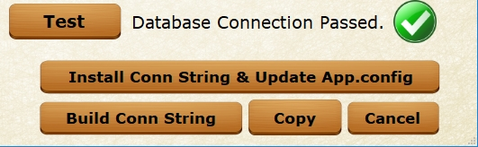

**Using Connection String Builder**

**Windows Authentication (recommended)**

If you are using Integrated Security, ensure your Windows Login has permission to execute stored procedures and modify data in your SQL Server.

**SQL Server Authentication**

**SA login:** If you are using the sa (system administer) account on SQL Server then you can skip the next section.

**SQL Server Login:**

Create a new SQL Server login named ‘DataTierNetUser’. Include the user in the following two roles: DataReader, DataWriter.

After you fill in the authentication options, the Build Conn String button will become enabled:

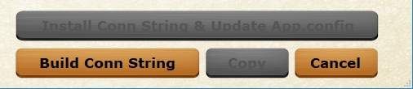

Once you build your connection string, the other buttons will become enabled as shown on the picture at the bottom of the previous page.

**Use Encryption** (optional)

By default, Connectionstrings are stored in plain text in the app.config file.

If this is a security problem, you may encrypt your Connectionstring.

Note: The default encryption key is unpublished for security reasons, but if you step through the code you can of course figure it out.

To choose your own encryption key, check the ‘Use Custom Key’ checkbox.

This will enable the Encryption Key Control as shown:

**Test Database Connection**

You should test your database connection before you click the ‘Install Connectionstring & Update App.config’ button.

Provided your Connectionstring works, you should see this message:



**Click the ‘Install Conn String & Update App.config’ button:**

You should see this message:

Five seconds after you see the installed message, the Connection String Builder Form closes, and you are shown a message that a restart is required:

**Restart Required**

The .Net Framework configuration files cannot be reloaded after app start.

Note: You must update the app.config running DataTier.Net in Visual Studio. I frequently run the executable version via a shortcut on my desktop, but this is after setup is complete.   
  
**Run Setup Again**

To run the Setup Control again, click the Run Setup Again button:

Note: The Setup Control only updates the app.config. I could update DataTier.Net.exe.config also, but the Setup Control is intended to help new users get up and running with DataTier.Net quickly.

**Manual Update App.config**

If you prefer to update the App.config manually, I left the instructions in:

**Use Encryption** (optional)

To use encryption in the app.config, change the value for UseEncryption to true.

Also set the EncryptionKey if you prefer to not use the default password.

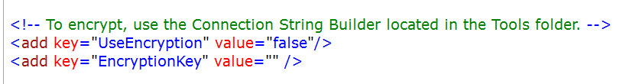

As the comment indicates, Connection String Builder is still located in the tools folder of the repo:

Tools Folder: DataTier.Net\DataTier.Net\Tools

Build your connection string and paste it into the app.config in DataTier.Net.

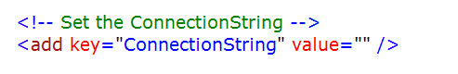

And the final step is to not show the setup guide is to set Setup Complete = true.

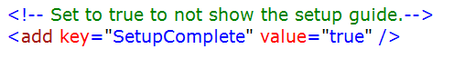

**Test Your Setup**

Tip: You may need to set the DataTier.Net.Client project as the start-up project in Solution Explorer in Visual Studio.

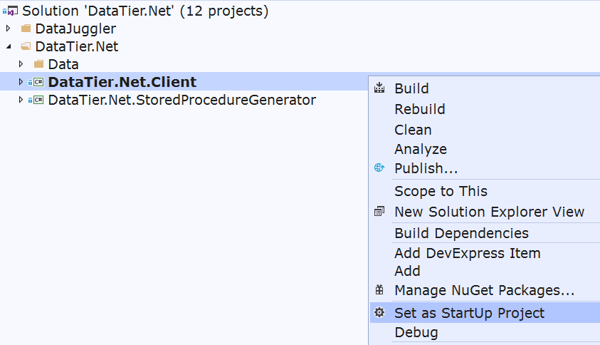

**Troubleshooting Connection Issues**

If you cannot connect to the Data Tier.Net database, the most likely cause is either the Data Tier.Net SQL Server database is not installed or the connection string is invalid in the file DataTier.Net.Client.app.config.

**Solving Security Problems**

It is outside of the scope of this document to solve SQL permission problems, but one useful stored procedure included in the DataTier.Net.Database could help.

The script is installed in the DataTier.Net.Database.

In SQL Server Management Studio, create a new query window and ensure the correct database is selected before running the following query

UpdateProcPermissions ‘DataTierNetUser’

I regret not saving the author of this procedure to give them credit, but this has saved me on numerous occasions.

**More Info About DataTier.Net Project Templates**

The project templates are used to help you create your own DataTier.Net projects by creating a Class Library which includes all the required references and projects required to build a DataTier.Net solution. The image below shows the directory structure of a Data Tier.Net Project Template:

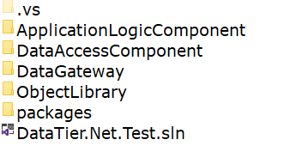

**Install DataTier.Net Project Templates**

As I mentioned in Step 2, there is now a VSIX installer to help you install the project templates.

Tip: You will need to restart VS after you run the DataTier.Net Project Templates.vsix installer to register the templates.

You are now ready to create your own projects!

**.Net Framework Creating a DataTier.Net DataTier**

**Create a DataTier.Net.ClassLibrary Project in Visual Studio**

In Visual Studio select File > New Project

This screenshot is from Visual Studio 2019.

**Note: .NET Framework projects cannot be installed from VS 2022.**

Type in DataTier.Net in the search box and select DataTier.Net.ClassLibrary.

Click the Next button. This will create your DataTier.Net.ClassLibrary project.

If DataTier.Net.ClassLibrary is not available, install the project templates as described in Step 2. Run Setup Again if needed.

**Install DataJuggler.Net NuGet Package**

.Net Framework Only. Dot Net Core packages are already installed.

Right click the solution and select ‘Manage NuGet Packages for Solution’ as shown above.

In the search box, type in DataJuggler.Net.

Select DataJuggler.Net and check the DataAccessComponent project.

Click Install and accept any prompts with ‘OK’.

Build your solution in Visual Studio.

**.NET5 / .NET6 Create DataTier.Net DataTier**

.Net Core projects are different as you start by creating a new project.

Click the New Project button and set the name and project folder.

Check the box for Dot Net Core Project, and this will show the Create Data Tier

Ignore the .Net Framework instructions below when they tell you to create a new project. Other than that, almost everything is the same with .Net Framework and .Net Core.

**Enable Blazor Features:**

If your project is a Dot Net Core project, you have the option to enable Blazor Features. If enabled, new features are available.

**Bindings**

I added a new enumeration to handle the BindingType.

You can select No Bindings, Allow Binding & Create Bindings.

**No Binding**

No Binding is the default option and your data objects will not be generated with callbacks enabled if changes occur.

**Allow Binding**

With Allow Binding, you must turn on binding for any tables you want binding.

I published a project on Git Hub with a working example of callbacks:

<https://github.com/DataJuggler/BlazorToDoList>

**Blazor Data Factory**

After I built my first project with Blazor, I realized I needed a way to intercept calls when changes occur so I can save the changes. I suspect as Blazor matures Microsoft is going to rethink their not letting you have an OnChange event with a bind property set. Until then, I think this is cool the way I did it.

**Services Folder**

The Services Folder defaults to DataGateway\Services, but you may change it.

**Create Data Services (for table)**

First you must install the Nuget package DataJuggler.DataTier.Net.Core.ItemTemplates.BlazorDataServices.

Then click the Create Data Services For (table) button.

This will create a DataWatcher and a DataService class tailored for the Selected Table.

**Example Data Watcher & Data Service:**

<https://github.com/DataJuggler/BlazorToDoList/tree/master/Data/DataGateway/Services>

**Data Watcher**

The Data Watcher is set after you load the data from SQL. Whenever data is saved or reloaded, the data watcher is set again to detect any changes.

**Data Service**

The Data Service calls Gateway methods and creates an easy way for the website to communicate with the datatier.

**Create a DataTier.Net Project**

Click the New Project button. This will launch the Project Wizard Control.

**Project Wizard.**

**New Project Wizard**

Type in a Name for your project and browse for or enter a Project Folder.

The project folder is the folder above the four projects in your data library.

Tip: An easy way to find your project folder is to right click your solution in Visual Studio and select ‘Open Folder in File Explorer’.

**Project Structure of a DataTier.Net Project**

The project folder is the folder above the four projects in your solution.

**Auto Fill Child Folders**

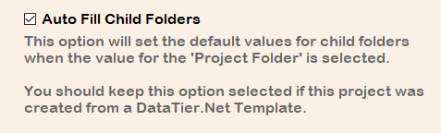

By default, this value is selected and will populate the other tabs of the project wizard for you. Leave this option selected, else use at your own risk.

**Add a database to your project.**

Click the ‘Next Button’ to select the database tab and click the Add button:

This will launch the Database Editor

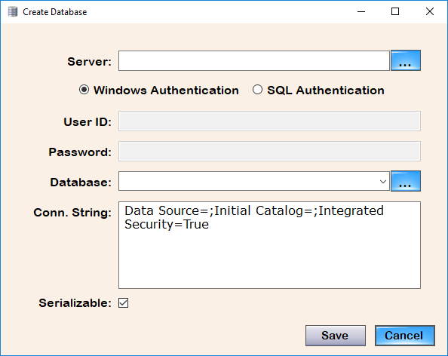

**Note:** this connection is only used by Data Tier.Net to retrieve the database structure. The connection string for your own DataTier.Net projects is configured in the app.config or web.config files in your solutions.

Tip: If you click the Server button to browse for Servers, you may need to add \SQLExpress to the server name detected. This is a known issue.

Provided the connection to the database can be established, when you click the Browse Database Button, the list of available databases will be populated.

Select the desired database then click the ‘Save’ button to save your database.

Click the ‘Save’ button again on the Project Wizard:

Update: 7.13.2019: Screenshot updated for DataTier.Net.

When you save your project, the database schema is read and then saved.

**Manage Data**

If you wish to exclude any tables, views or fields from your project, click the Manage Data button before you build.

If you exclude any tables or fields, the Save button will become enabled.

Note: Views are listed as tables, although their behavior is different.

Click ‘Save’ if you make any changes. Click Done to exit this form.

**You are now ready to build your project with DataTier.Net!**

**Build Your Project**

Clicking the Build All Button will code generate all the required objects and stored procedures to assemble your data tier.

**Include the generated files in your project**

New Files that are generated must be included into your Visual Studio solution.

When you rebuild your project with DataTier.Net, you will only have to include new files if you add a new table or view.

If DataTier.Net determines that new files were added, the Visual Studio Project Updater will launch after you build.

**Using the Visual Studio Project Updater Control**

**.Net Framework Only**

Step 1: Select the DataTier.Net.ClassLibary VS solution file (.sln).

Data Tier.Net will read the project names from the solution file.

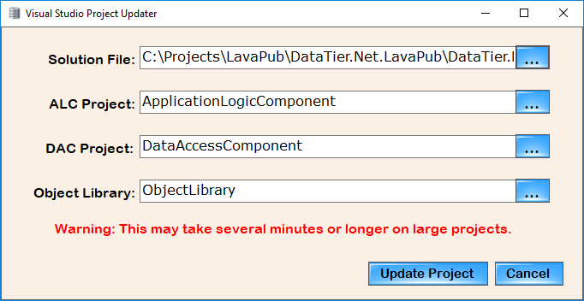

If you created your project from a DataTier.Net.ClassLibrary project template the names will be correct. You can rename your projects after creating from a Data Tier.Net project template.

If the project names are not detected, click the browse button for each project and a browse dialog for each project file will launch.

After your projects are selected, click the Include Project Files button. This will include any files in your project that were generated during the last build.

**5.1.2019: The Include Project Files Button Is now clicked on your behalf.**

Often, I would forget to click the Include Project Files button, and I would have to manually include all the required project files, and it is quite a tedious job.

You should not have to manually include project files now, but for anyone that ever has this need I will leave the instructions in.

**Manually include files in your project**

After building your project you must include your project files into your Visual Studio solution.

Step 1: Open your Visual Studio project, and in Solution Explorer, click the Show All Files button as shown here.

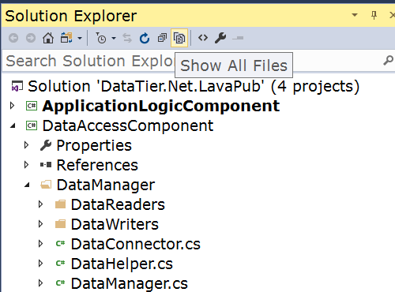

Toggling the Show All Files Button; this will refresh Solution Explorer to show any files that are on the file system but are not included in your project.

Select any file(s) you wish to include in your project and then right click and select the option “Include in Project”.

There are a total of about 10 directories that will need to include files that have been code generated into.

The following is a list of folders to include after you build a Data Tier.Net project.

**Project:** Application Logic Component

**Folders**: Controllers

Data Operations

**Project:** Data Access Component

**Folders:** DataManager

DataReader

DataWriter *

StoredProcedureManager\Delete Procedures

StoredProcedureManager\Fetch Procedures *

StoredProcedureManager\Insert Procedures

StoredProcedureManager\Update Procedures

**Project**: Object Library

**Folders**: BusinessObjects *

* All objects in most tables will have a single file per table.

The following objects have two files per table included in the folder.

The Fetch Procedures will create a find (single instance returned) and a FetchAll method returns a List<T>, where is T = the class object created for your table.

The Data Writers create a base class and a derived class for each table.

The Business objects use partial classes so for each table there will be two files created:

<Table Name>.business.cs, <Table Name>.data.cs

Place any customizations in the .business class, as the .data class will be overwritten each time you build with DataTier.Net.

**Executing the StoredProcedures.sql**

**Update 4.2.2019: Click the link ‘Stored Procedures.sql’ in DataTier.Net**

The file is kind of buried, so I added this link to make it exponentially easier to find. Provided you have SQL Server Management Studio installed, Data Tier.Net will launch SSMS and open the stored procedures.sql file that was just created.

Location of stored procedures.sql in the Data Access Component project:

StoredProcedureManager\StoredProceduresSQL\storedprocedures.sql

After executing the stored procedures, you should see a message like:

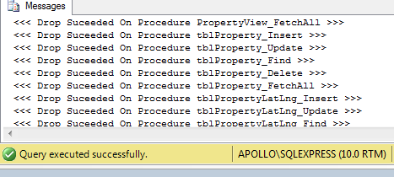

**Update 12.19.2012: Gateway Generator**

The gateway is now code generated when you build.

**Load Method**

For each table or view in your database, the gateway will create a Load method.

Update 4.5.2019: The above documentation does not state that now each ‘Active’ table will create a Load method. Tables can now be excluded, but for the remainder of this section, just keep this point in mind.

**Delete, Find and Save Methods**

For tables that have an Identity Insert (auto-number) primary key, the Delete, Find and Save methods will be code generated.

Update 4.5.2019: The main engine of DataTier.Net, DataJuggler.Net.SQLDatabaseConnector, is now more robust than it was when this ‘must be identity insert’ rule was implemented. I just haven’t had time to implement this.

Once I publish, volunteers are invited to help make improvements.

**Save Method**

The Save method analyzes the IsNew property of the object being saved, and calls Insert or Update accordingly.

**Bypassing the Gateway**

You may bypass the Gateway if you choose, and create an instance of the AppController as shown here:

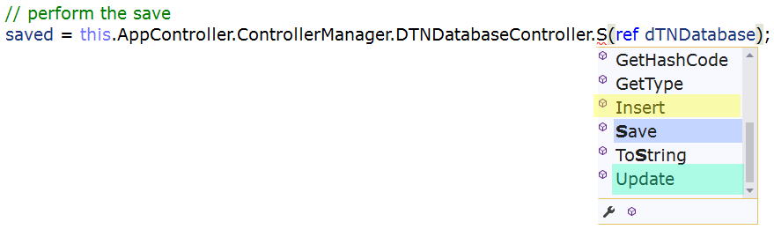

You may choose to directly call Insert or Update in the controller for the table and bypass the Gateway.

Read the DataTier.Net User’s Guide for more information.

Please check out my YouTube channel, as I will update videos and sample projects as often as I am able. My pesky day job gets in the way of creativity but allows me to eat to continue being creative; thus, a paradox.

<https://www.youtube.com/channel/UCaw0joqvisKr3lYJ9Pd2vHA>

**Sample Projects built using DataTier.Net.**

**DB Compare** <https://github.com/DataJuggler/DBCompare>

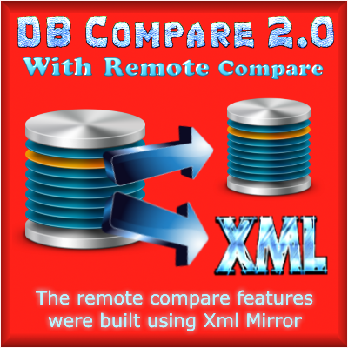

DB Compare compares the schema from two SQL Server databases and reports any schema differences. The core component of DB Compare is the file DataJuggler.Net.SQLDatabaseConnector; the same object used by Data Tier.Net to read database schema.

**XML Mirror** <https://github.com/DataJuggler/XmlMirror>



I created XML Mirror during one of my previous employments, which involved parsing large amounts of XML data.

XML Mirror uses the class CSharpClassWriter to create the following files:

Parser.base.cs Parser.custom.cs

DataJuggler.Net.CSharpClassWriter is the same file used in Datatier.Net to code generate files.

After Xml Mirror was created, I updated DB Compare to perform remote comparisons of a SQL Server database located on a virtual machine, against a database you can connect to via a connection string, or vice versa.

Prior to this feature in DB Compare, I would have to remote into the VM, and bring with me a schema only copy of my database to perform a compare.

I hope after reading the above explanation, you understand one of the reasons all my projects are shared in one large repo.

The other is simply a time saving device. If I tried to manage all these projects, I wouldn’t do any of them justice, but since I do use all this code it will get updated.

**Data Tier.Net FAQ**

**Question:**

Do I have to use a Data Tier.Net template to create a Data Tier.Net project?

**Answer:**

No. The Data Tier.Net templates are a time saving tool that you can use if you choose to. If your project would be better suited with a different structure then the templates provide, then feel free to modify your project to suit your needs. Just remember only the template structure has been tested and is supported.

**Question:**

Data Tier.Net uses multiple projects; can all the required folders be placed in a single project?

**Answer:**

I once built a single project and it worked, but I prefer the data tier be separated so it is more portable.

**Question:**

Can a project have multiple databases?

**Answer:**

The client allows you to create multiple databases and the Data Manager has a databases collection, but I have never built a project using multiple databases in one data tier.

Whenever I use Data Tier.Net for data migrations I create two projects and add them both to one solution. Both projects have their own Data Connector and Gateway. You must manage the multiple connection strings yourself.

**Question:** I created a project from a Data Tier.Net Template and noticed that there are some files with names like TemporaryDeleteProcedure.cs.

Is this class needed for anything?

**Answer:**

No temporary classes are only used as a placeholder until you have built a Data Tier.Net project and so the references will compile. Feel free to delete these temp files after you have “real” classes in your project.

**Final Thoughts**

If you like Data Tier.Net and have any positive feedback, questions or comments please create an issue on the Data Juggler Shared Repo on GitHub.

I want to hear what the community wants, as everything up to this point has been what I have wanted.

**Data Tier.Net vs Entity Framework**

I do not make any claims that DataTier.Net is better than Entity Framework. Entity Framework is Microsoft’s recommended data access component, and I use it at my day job in addition to DataTier.Net. Entity Framework has been tested by thousands of engineers and testers inside of Microsoft, and hundreds of thousands if not millions of developers outside of Microsoft.

My reasons for why I prefer DataTier.Net over Entity Framework are discussed in this video here:

<https://www.youtube.com/watch?v=wFP6sm3pjoY>

**Finding Errors with DataTier.Net**

If a save fails, finding the last error is very simple in DataTier.Net:

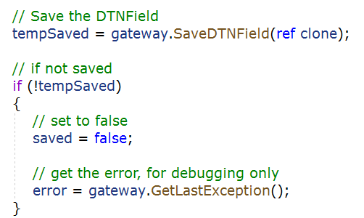

I hope you enjoy DataTier.Net.